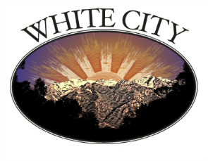

Topic: White City Council Meeting

Location: 999 East Galena Drive, White City, UT 84094

Time: Aug 7, 2025 06:00 PM Mountain Time (US and Canada)

Join Zoom Meeting

https://us06web.zoom.us/j/85347303412?pwd=eRvk6MF2i5osx8vcobCrzmVGj7oGcy.1

View meeting insights with Zoom AI Companion

https://us06web.zoom.us/launch/edl?muid=d1e8308c-4df0-4d41-9bc6-cabda7f348d3

Meeting ID: 853 4730 3412

Passcode: 083874

---